Layman’s report

Deliverable D1.6

🟢 What is the Zerosilibrine Project?
Zerosilibrine is an innovative solution that transforms saline wastewater from precipitated silica production into reusable water and commercial-grade sodium sulfate. By eliminating discharges and recovering resources, it demonstrates how circular economy can be applied in heavy industry.
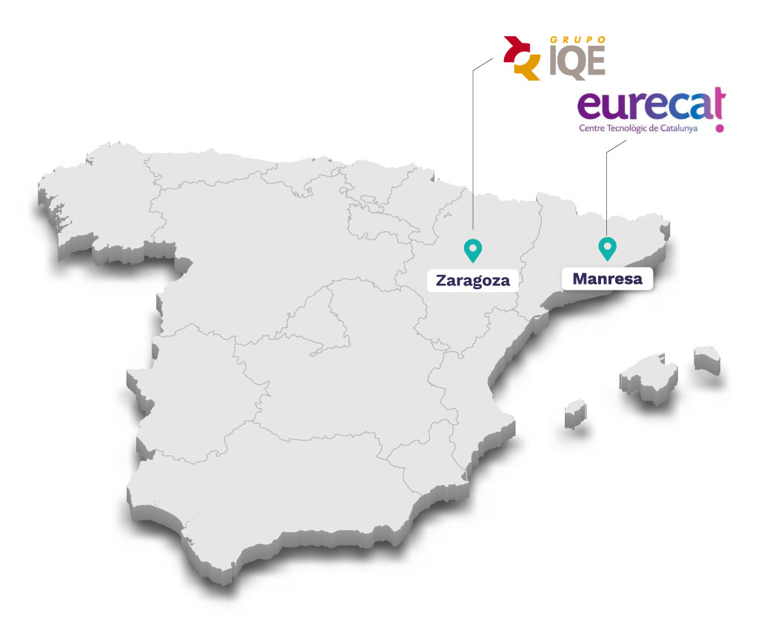
🟢 Budget and project’s implementors:

Total amount: 3,200,605 €
% EU Contribution: 1,760,332 € (55%)

Start on : 01/09/2021
Final on : 30/06/2025

Coordinating Beneficiary (81.6%):
Industrias Químicas del Ebro S.A.
Contact : mcano@iqe.es

Associated Beneficiary (18.4%):
Fundació Eurecat (Eurecat)

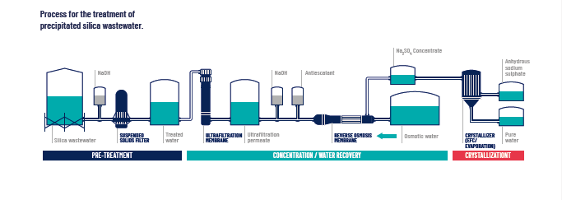
🟢 Main Achievements
Industrial unit scheduled for 2026/2027:
- Recovery of 18,500 tons/year of sodium sulfate (Na₂SO₄).
- More than 1.3 million m³/year of water reused.
- Zero discharge to natural water bodies.
- Reduced groundwater dependence by 70%.
- Use of energy-efficient MVR technology.

🟢 Environmental and Social Impact
Zerosilibrine contributes to the EU Green Deal and supports SDGs by:
- Protecting ecosystems and river salinity.
- Enabling water reuse in industry.
- Promoting sustainable innovation.

🟢 Economic Viability

Operating Scenarios Summary
Scenario | Na₂SO₄ Output (t/y) | Unit Cost (€/t) | Revenue (€/y) | Net Profit (€/y)
Pilot (no MVR) | 300 | 566.11 | €36,000 | –€95,219.59
Pilot with MVR | 2,179 | 34.16 | €261,480 | +€91,647.04
Industrial (2026) | 18,499 | 45.19 | €2,219,880 | +€1,383,945.80

Resource Savings (Industrial Scenario)
Resource Saved | Quantity | Savings (€)
Well water | 1,290,000 m³/year | €757,686.77
Discharge fees | 1,296,000 m³/year | €635,040.00
NaCl brine | 1,000+ tons/year | €40,815.03
Total Annual Savings | — | €1,433,541.80

🟢 ZEROSILIBRINE AT A GLANCE

➤ 18,499 tons/year of Na₂SO₄ recovered
➤ 1.3 million m³/year of water reused
➤ €1.38 million net profit per year
➤ Zero discharge — full water circularity
➤ 60% energy savings with MVR
➤ EU Green Deal and SDG alignment
➤ Industrial unit commissioned in 2026/2027
📊 Impacts:
- 💧 70% reduction in water extraction
- 🌱 Elimination of river salinization
- ⚙️ 10.1-year CapEx payback
- 🌍 Scalable to paper, textile, mining sectors
📦 Outputs:
- Sodium sulfate (technical grade, dry)
- Osmosis water (recycled)
- Circular brine (used internally)
♻️ A sustainable, replicable model for zero-waste industrial production

